REQUEST FOR INFORMATION FOR

CANADIAN PRESCRIPTION DRUG IMPORTATION PROGRAM
Prepared For: FLORIDA AGENCY FOR HEALTH CARE ADMINISTRATION

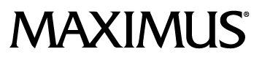
RFI 003-18/19
June 25th, 2019
MAXIMUS RFI Response

- Contact Information

B. A statement of interest in the services outlined in this RFI, including an outline of a specific product, concept, technology, or approach that would meet the goals and requirements described in this RFI;

MAXIMUS has reviewed the RFI and offers our unique experience and capabilities to assist the Agency with the implementation of this program. MAXIMUS is truly unique in that we have extensive experience administering government health programs here in the United States such as Medicare, Medicaid, CHIP, and related programs AND deep knowledge and understanding of the Canadian drug market. MAXIMUS has health care projects in 36 States and 11 Provinces and Territories in Canada.
In order to ensure the integrity of this program, the entity that assists the Agency in the administration and management must be conflict free. An entity that may profit from the drug importation should not be in a position to also oversee the program. This will ensure that all decisions and actions are in the best interests of the Agency and the citizens of Florida.
MAXIMUS has zero ties to health plans or providers, guaranteed. A conflict of interest may exist when a contractor has an interest, financial or otherwise, in the outcome of its services or a relationship with an individual or contractor that could influence the outcome of its services. Conflicts of interest, whether real or perceived, can undermine the effectiveness of government programs as well as public confidence and trust in the programs’ integrity.
MAXIMUS is committed to offering conflict-free services to government. It is critical for the work that we perform as the largest independent administrative services organization, supporting 70 percent of all Medicaid and CHIP beneficiaries in the country and as the largest Qualified Independent Contractor of Medicare appeals.
By concentrating our practice on public sector clients, MAXIMUS has created a culture in which our priority is helping our government clients implement and execute public policy. Conflict of interest concerns are important not just to the governments we serve, but also to the most vulnerable beneficiaries of health and human services programs. The absence of conflict, whether actual or in appearance, is essential to maintaining the citizen’s confidence in their government. Government leaders demonstrate that they are working in the best interests of the people they serve by avoiding real or perceived conflicts of interest. MAXIMUS is firmly committed to remaining conflict-free to ensure the integrity of public programs and retain the trust of citizens.
MAXIMUS Approach to the Proposed Vendor Responsibilities

On an annual basis, develop a list of the prescription drugs that have the highest potential for cost savings to State of Florida programs, including prescription drugs for which there are shortages, specialty prescription drugs, and high-volume prescription drugs.

MAXIMUS will assist the agency in an extensive analysis of drug usage across the State of Florida’s health programs. This could include Medicaid, CHIP, State employees, State retirees, Workman’s Compensation, Disability and other programs. This annual analysis will look at volume, cost, availability, new drugs entering the market, and other criteria to determine potential cost savings. MAXIMUS will work with the Agency to then set priorities for potential importation of those drugs.
Identify Canadian suppliers that are in full compliance with relevant Canadian federal and provincial laws and regulations and who have agreed to export drugs at prices that will provide cost savings to the State.

Based on our experience with the Canadian drug market, MAXIMUS will identify Canadian suppliers of the drugs identified in the fiscal analysis. We will then determine the supplier’s interest or willingness to export the drugs to the U.S. We will also determine their compliance with federal and provincial laws and regulations. MAXIMUS will audit this information as required throughout the program.
Contract with such eligible Canadian suppliers, or facilitate contracts between eligible importers and Canadian suppliers, to import drugs under the program.

As MAXIMUS believes that the administrator of this program should not also be a party to the actual import transactions, we will facilitate contracts between eligible importers and Canadian suppliers, to import drugs under the program. MAXIMUS will maintain a Program Document and Data Repository of these contracts and other program documentation on behalf of the Agency.
Maintain a list of all importers that participate in the program.

MAXIMUS would maintain the list of all approved importers. MAXIMUS also recommends checking this list monthly against Florida, DEA, CMS, and other databases to identify any information that may indicate actual or potential fraud and abuse.

Ensure all participants in the program comply with Title II of the Federal Drug Quality and Security Act, Pub. L. No. 113-54.

MAXIMUS recommends the vendor perform regular audits of the all entities participating in the drug importation program to ensure compliance with Title II of the Federal Drug Quality and Security Act.
Ensure that eligible importers have documentation that sample testing of the prescription drugs occurred at a qualified laboratory, as required by 21 U.S.C. 384.

MAXIMUS recommends the vendor perform regular audits of the all eligible importers participating in the drug importation program to ensure that documentation of sample testing of the prescription drugs occurred at a qualified laboratory, as required by 21 U.S.C. 384.
Ensure that there is documentation that the imported prescription drug has been certified as being approved for marketing in the United States, has not been adulterated or misbranded, and meets all labeling requirements under federal law.

MAXIMUS recommends that the program include scope for a quality management function. This would include the scope defined in this section as a minimum but could also include more extensive measures to ensure proper labeling, drug quality, etc.
Maintain additional information and documentation from importers and Canadian suppliers as specified in HB 19.

As part of the Program Document and Data Repository described above, MAXIMUS would maintain all required documentation sent to or received from program participants. This fully secure repository would be available to the Agency in real time.
Assist the Agency in the preparation of an annual legislative report on the efficacy of the Program.

MAXIMUS will assist the Agency in the preparation of this annual legislative report. MAXIMUS will also ensure that the necessary information is gathered and documented throughout each program year that is required to meet the requirements of HB 19. The annual report will, at a minimum, include the following information for the previous fiscal year:
- A list of prescription drugs that were imported under the program.
- The number of participating entities.
- The number of prescriptions dispensed through the program.
- The estimated cost savings during the previous fiscal year and to date.
- A description of the methodology used to determine which prescription drugs should be included on the vendor’s Wholesale Prescription Drug Importation List.
- Documentation demonstrating how the program ensures that:
- Canadian suppliers participating in the program are of high quality, of high performance, and in full compliance with relevant Canadian federal and provincial laws and regulations and U.S. federal and state laws and regulations;
- Prescription drugs imported under the program are not shipped, sold, or dispensed outside of the state once in the possession of the importer;
- Prescription drugs imported under the program are pure, unadulterated, potent, and safe;
- The program does not put consumers at a higher health and safety risk than if the program did not exist; and
- The program provides cost savings to the state on imported prescription drugs.

C. A description of the respondent’s business and its experience as it relates to the services outlined in this RFI. This description should include a narrative explaining past experiences related to pharmaceutical importation or exportation. The respondent shall indicate any international or wholesale distribution experience it has for services similar in nature to those described in this RFI.
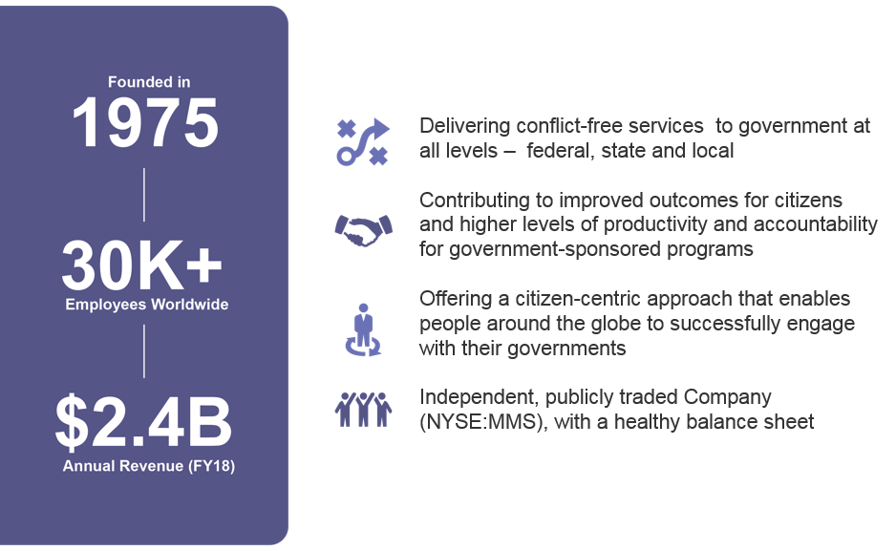
Since its establishment in 1975, MAXIMUS, Inc. has been a trusted vendor of state, federal, local, and international government entities in the United States, Canada, the United Kingdom, Saudi Arabia, and Australia; providing critical health and human service programs to a diverse array of communities. Our core mission of "Helping Government Serve the People®" is at the heart of our commitment to delivering the most effective solutions in the most efficient manner possible, and it forms the basis of everything we do. By concentrating our practice on public sector clients, MAXIMUS has created a culture in which our sole priority is helping our government clients implement and execute public policy. Our company currently employs 20,000 people and organized into four units; Health, Human Services, Federal Government, and Global. We are a publicly traded company listed on the New York Stock Exchange (NYSE) under the symbol (MMS).
MAXIMUS has been operating large-scale health service projects since 1992, and Medicaid and customer service projects since 1995, developing effective solutions for our government clients every step of the way. In addition, our health care operational services encompass support for long-term care programs, assessments, and care planning for the elderly and persons with disabilities, health insurance exchanges, eligibility and enrollment modernization, and health information system technology consulting. Over the course of our history, we have helped our clients meet virtually every kind of challenge that program operations can present, which has allowed us to develop the flexibility to respond to new challenges that come with evolving service needs and policy priorities.
MAXIMUS Canada
In Canada, MAXIMUS has been engaged in pharmacy claims processing and health care program operations for almost 20 years. On behalf of British Columbia's Ministry of Health, MAXIMUS administers the province's medical and drug insurance plans under the Health Insurance BC program. MAXIMUS provides program enrollment and registration services, account management, claims processing and payment, and information for more than 4.5 million residents and more than 13,000 health care providers. These numbers translate annually into:
- More than one million phone calls
- More than 100 million provider claims processed (Medicare and pharmacy program claims)
MAXIMUS also assists many of Canada’s provincial health programs with the administration of their drug benefit programs. MAXIMUS supplies our leading-edge drug management systems to the provinces and territories. This includes the Medigent® pharmacy benefits management system, and the Medigent® Drug Information System (DIS).
- British Columbia: Management and administration of the Provincial Medicare, Pharmacare, and DIS programs
- Yukon Territory: Beneficiary Management, Provider Registration, Medical claims, Pharmacy claims, Medical Transportation claims, and DIS
- Northwest Territories: Beneficiary Management, Provider Registration, Medical claims, Medical Transportation claims, and Vital Events Management
- Nunavut Territory: Beneficiary Management, Provider Registration, Medical claims, Pharmacy claims, Medical Transportation claims, and Vital Events Management
- New Brunswick: DIS
- Prince Edward Island: Beneficiary Management, Provider Registration, Medical claims, Pharmacy claims, Dental claims, DIS, and Vital Events Management
- Nova Scotia: Reciprocal Medical Claims and DIS
- Newfoundland and Labrador: Pharmacy claims
- Self-governing Inuit Nation of Nunatsiavut: Pharmacy claims and Dental claims
- Ontario: Beneficiary assessment and enrolment services for the Province’s low income drug program
Our long and rich experience with the pharmaceutical market in Canada will be of enormous value to the Agency as it implements this program.
D. An estimate of administrative and operational costs associated with implementing the Program.
The cost to implement a program as described in our response can vary greatly depending on the state’s requirements. MAXIMUS would prefer to discuss rough order of magnitude (ROM) pricing directly with the State.
E. An estimate of ongoing administrative and operational costs associated with sustaining the Program.
The cost to operate a program as described in our response can vary greatly depending on the state’s requirements. MAXIMUS would prefer to discuss rough order of magnitude (ROM) pricing directly with the State.

F. An estimated timeline for Program implementation.
MAXIMUS has extensive experience implementing new and innovative programs. We believe as program as described on our response can be implemented and ready to operate within 6 months of notice to proceed.
G. A description of innovative ideas and strategies in providing the services described in this RFI. As a part of the response, include any potential implementation challenges that the respondent believes the Agency should consider during the Program design phase and potential solutions.
As stated above, In order to ensure the integrity of a program, the entity that assists the Agency in the administration and management of the program must be conflict free. An entity that may profit from the drug importation should not be in a position to also oversee the program. This will ensure that all decisions and actions are in the best interest of the Agency and the citizens of Florida.

